DETACHMENT 890
CADET HANDBOOK

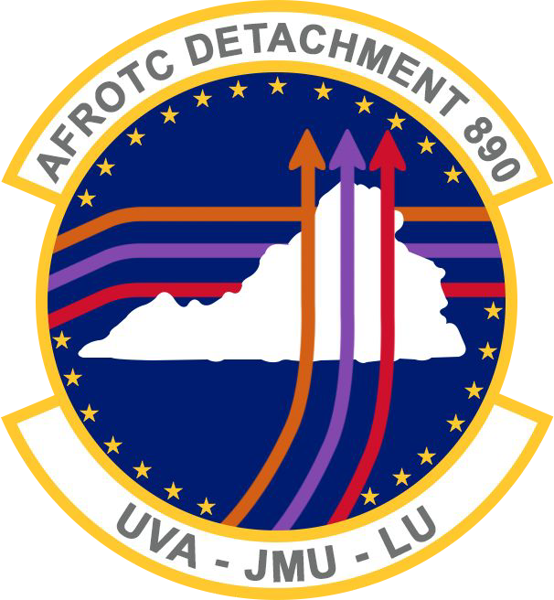

afrotc.virginia.edu afrotc@virginia.edu (434) 924-6831

Table of Contents

1. Introduction 3
2. Cadet Classification 4
3. AFROTC Curriculum 5
4. Cadet Wing 6
5. Customs and Courtesies 8
6. Uniform Wear 11
7. Physical Fitness 20
8. Basic Knowledge 24
9. Reporting Civil and Medical Involvements 38
10. Email Communication Basics 39
11. Detachment Discipline Standards. 41
12. Frequently Asked Questions 42
13. DET 890 Cadet Activities and Maps……………………………………………………………... 44
14. Resources……………………………………………………………………………………………. 48

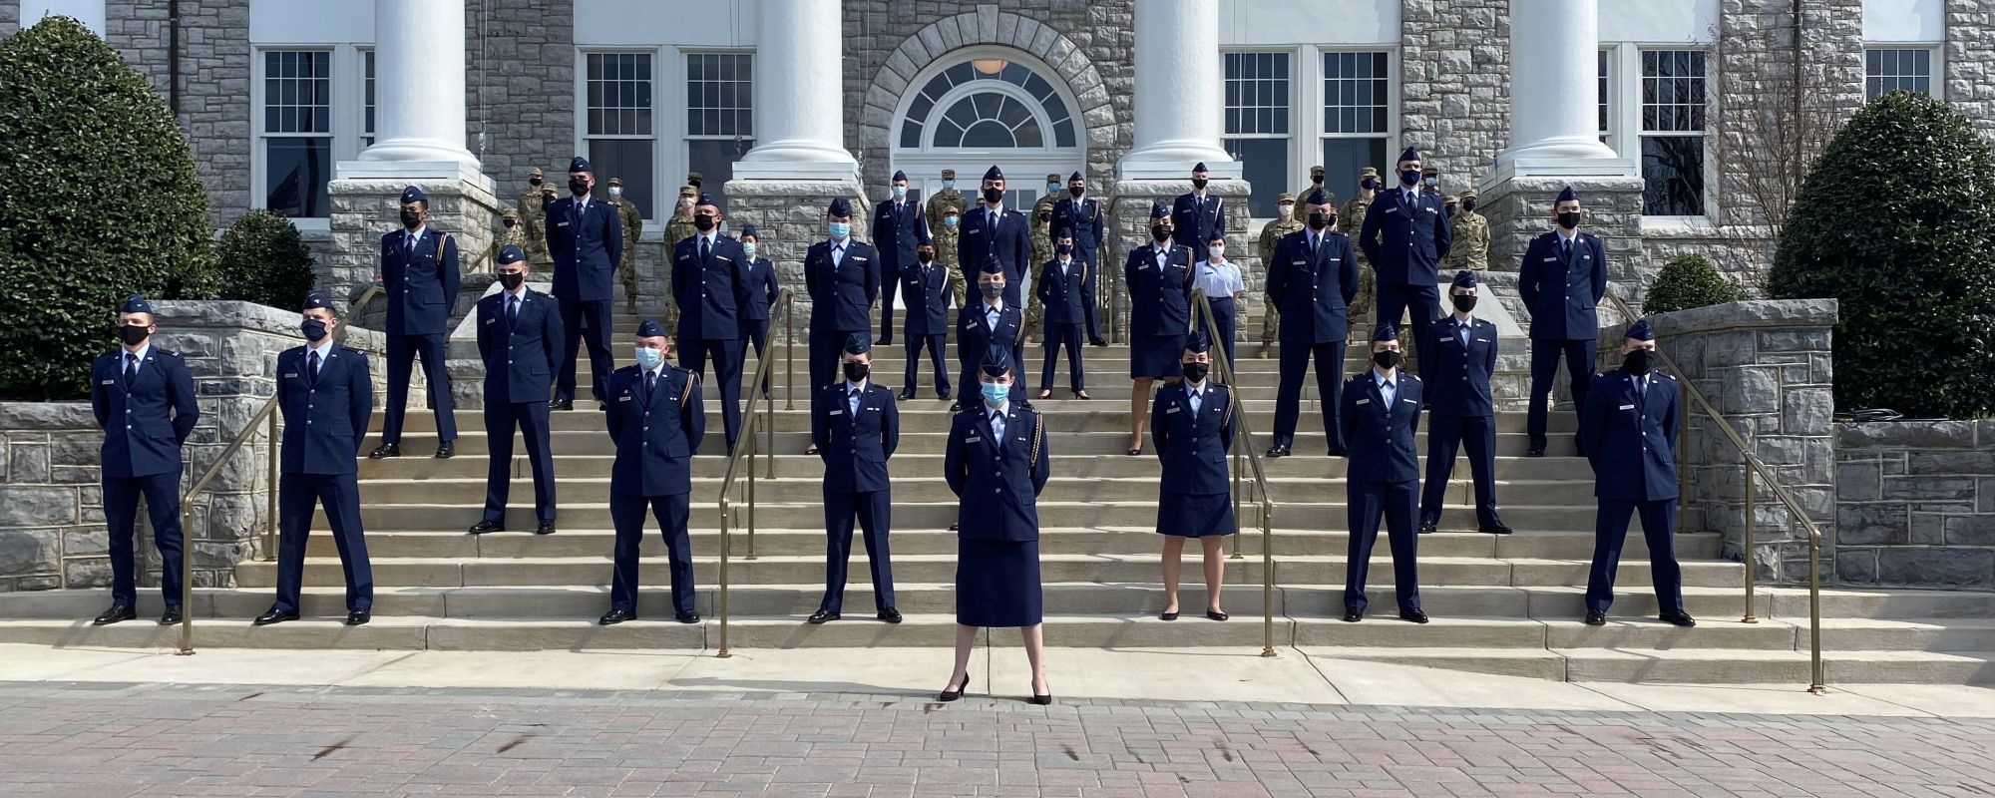

Introduction

Welcome to Air Force Reserve Officers Training Corps (AFROTC) Detachment 890. This guidebook has been created to assist cadets in the AFROTC program at Liberty University, James Madison University, and the University of Virginia. It is intended to provide quick guidance to the customs, courtesies, life in AFROTC, and basic knowledge of the United States Air Force (USAF) and the United States Space Force (USSF). Whether you have prior military experience, Junior ROTC experience, or no military experience, this guide sets forth the basic military principles and policies required of a cadet. There are many ways to get involved and be a viable part of the 890th Cadet Wing. We are looking forward to an outstanding semester and welcome you to the program.

If there are any questions or comments concerning the information contained within this guide or if you feel that any additional content should be added, please contact either the Cadet Wing Vice Commander (if you are a Professional Officer Course (POC) cadet) or the General Military Course Liaison (GMCL) (if you are a General Military Course (GMC) cadet).

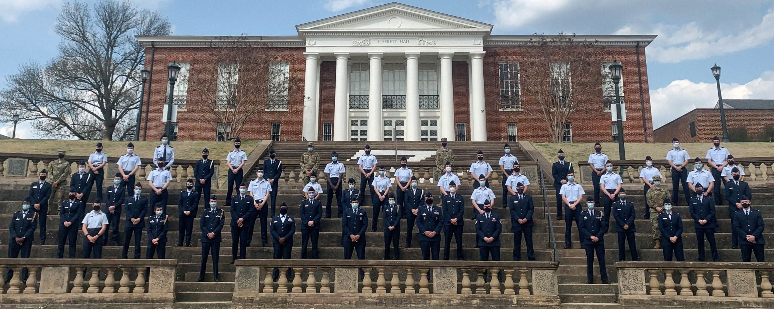

2. Cadet Classification
2.1. The General Military Course (GMC). The first and second years of the 4-year AFROTC program consist of two sub courses: Initial Military Training (IMT) and Field Training Preparation (FTP).

    - IMT Cadets: Provides new cadets with basic skills and knowledge needed to be a functional member of the cadet corps. Activities are designed to build camaraderie and esprit de corps, as well as help them develop followership and teamwork skills.

    - FTP Cadets: Provides training that ensures cadets are adequately prepared mentally and physically for the rigorous field-training environment.

  - The Professional Officers Course (POC). Normally, the third and fourth years of the 4-year AFROTC program, consisting of two sub courses: Intermediate Cadet Leaders (ICL) and Senior Cadet Leaders (SCL).

    - ICL Cadets: Provides intermediate cadet leaders, typically AS 300 cadets that are Field Training graduates, the opportunity to further develop the leadership and followership skills learned at field training. Intermediate cadet leaders will be given the opportunity to sharpen their planning, organizational, and communication skills, as well as their ability to effectively use resources to accomplish a mission in a constructive learning environment.

    - SCL Cadets:. Provides soon to be commissioned cadets, typically AS 400’s, with additional opportunities to develop their leadership and supervisory capabilities and prepares them for their first Active Duty assignment. It also provides the opportunity to develop and receive feedback on the leadership skills they will be expected to possess when they arrive at their first duty station.

3. AFROTC Curriculum

The AFROTC curriculum is the principal instrument by which AFROTC cadets are educated, motivated, and trained for AF commissioned service. The curriculum consists of three primary areas: the AS courses, LLAB, and Physical Training (PT). In addition to the curriculum, cadets must attend and satisfactorily complete Field Training (FT).

Aerospace Studies Courses.

3.1.1. GMC. The GMC is a two-year course, consisting of AS 100 and AS 200, designed to motivate and prepare cadets for entry into the POC. Each course is designed as a weekly, one academic-hour course.

      - AS 100. The AS 100 curriculum, entitled: “Heritage and Values,” is a survey course designed to introduce students to the United States Air Force and Space Forces and provides an overview of the basic characteristics, missions, and organization of the Air and Space forces.

      - AS 200. The AS 200 curriculum, entitled “Team and Leadership Fundamentals,"
provides a fundamental understanding of both leadership and team building. The lessons and course flow are designed to prepare students for field training and leadership positions in the detachment.

      - AS 500. These cadets have completed the GMC curriculum.

    - POC. The POC is a two-year course, consisting of AS 300 and AS 400, designed to prepare cadets for active duty as AF officers. Each course in the POC is designed as a weekly ,three academic-hour course.

      - AS 300. The AS 300 curriculum, entitled “Leading People and Effective Communication,” utilizes students’ field training experience to take a more in-depth look at leadership. Special emphasis is placed on enhancing communication skills, and why that is important as a leader. Students have an opportunity to try out these leadership and management techniques in a supervised environment as juniors and seniors.

      - AS 400. The AS 400 curriculum, entitled: “National Security/Commissioning
Preparation,” is designed for college seniors and gives them the foundation to understand their role as military officers and how they are directly tied to our National Security Strategy. It is an overview of the complex social and political issues facing the military profession and requires a measure of sophistication commensurate with the college level.

      - AS 700/800/900. These cadets have completed the POC curriculum.

3.2. Leadership Laboratory. The purpose of the LLAB program is to augment the AFROTC academic curriculum by providing cadets with dynamic activities, opportunities, and feedback needed to develop the leadership, managerial, and supervisory skills required of successful AF officers. It is a student planned, organized, and executed practicum conducted under the supervision of the cadre. LLAB provides a training environment in which each cadet can develop and exercise the skills and techniques necessary for success as an Air Force officer. LLAB normally consists of a 2-hour session, 1530-1730 hours on Tuesdays for James Wing and Thursdays for Day Wing. Activities that complement LLAB objectives take place throughout the semester.

3.3. Field Training (FT).

In order to become a member of the POC, a GMC cadet must compete for and receive a slot to attend one of the AFROTC FT encampments. This “slot” is referred to as an Enrollment Allocation (EA).

FT is a mandatory program for all individuals qualified to pursue an AF commission through AFROTC. Cadets usually attend FT during the summer between their sophomore and junior year. The purpose of FT is to provide an appropriate environment to evaluate a cadet’s military leadership potential and discipline.

FT is an intense environment that provides a mental, physical, and emotional challenge while stimulating the development of military leadership. The FT curriculum consists of physical conditioning, drill and ceremonies, leadership and followership training, career exposure, academic instruction, values clarification, and personal development. Satisfactory completion of FT is a requirement for entry into the POC.

Physical Training (PT).

The goal of the PT program is to enhance the physical fitness level of cadets and motivate cadets to pursue a physically fit lifestyle. Every cadet must attend at least 3 sessions of physical activity each week. These sessions are organized by the Cadet Wing.

4. Cadet Wing

The Cadet Wing Commander is selected by cadre. The Cadet Wing Commander, with cadre coordination, then selects the Cadet Wing, Group, and Squadron staffs. Cadets are selected for these key positions based upon their demonstrated traits of leadership, character, motivation, academic standing, military bearing, and needs of the corps.

Detachment 890 contains two functioning Cadet Wings, Day Wing located at Liberty University and James Wing at the University of Virginia to which cadets from James Madison University travel.

4.1. Commissioned Officers and Professors.

4.1.1. Detachment Commander (Det/CC). The Det/CC is the senior AF member on duty at Detachment 890. S/he is the Commander of AF personnel assigned to the detachment.

4.1.2. Operations Officer (DO). The DO is the next senior AF member on duty at Detachment 890. S/he supervises all unit operations, recruiting, and education functions and acts on behalf of the Commander in his/her absence.

4.1.3. Operation Flight Commander (OFC) - UVA/JMU. The OFC is primarily responsible for cadet training, to include the enforcement of military and academic standards. The OFC works very closely with the Cadet Wing Commander.

4.1.4. Operation Flight Commander (OFC) - LU. The OFC is primarily responsible for cadet training, to include the enforcement of military and academic standards. The OFC works very closely with the Cadet Wing Commander.

4.1.5. Education Officer (EO). The EO is in charge of educational and commissioning requirements for all cadets.

4.1.6. Recruiting Officer (RO). The RO is in charge of Detachment recruiting activities.

4.2. Non-commissioned Officers.

4.2.1. NCOIC. The Non-Commissioned Officer in Charge (NCOIC) supervises the other enlisted members and is responsible for all administration and personnel processes at Detachment 890.

4.2.1. NCOIC, Personnel. The Non-Commissioned Officer in Charge (NCOIC) for Cadet Personnel is responsible for enlistments, disenrollments, security clearances, cadet pay, scholarship activation, assignments, and commissioning.
4.2.2. NCOIC, Administration. The NCOIC for Administration is responsible for records management, supply procurement, equipment accountability, physical exams, field training, suspense control, and publications.

5. Customs and Courtesies

5.1. Military customs. Military customs are mannerisms passed as tradition. Customs and traditions provide the framework of AF heritage. The most important tradition of an AF officer is to maintain a high degree of integrity. Military courtesies are polite and considerate behavior often linked to customs. Lack of military courtesies can bring disciplinary action. The following is not a complete list but among the most meaningful.

5.1.1. ALL cadets will be addressed as Cadet and their last name (i.e., Cadet Jodie).

5.1.2. The place of honor is always on the right. A junior walks, sits, or rides on a senior’s left. When boarding a vehicle, the senior enters last, and when departing a vehicle, the senior leaves first. A senior always enters the door first.

5.1.3. If seated, all cadets will stand when addressed by an officer, non-commissioned officer, or a senior cadet.

5.1.4. Cadets will rise when a commissioned officer enters the room and render a verbal greeting unless a higher-ranking officer is already in the room.

5.1.5. Cadets should refrain from placing their hands in their pockets while in uniform.

5.1.6. Ensure your actions and attitude always reflect upon your professionalism.

5.1.7. Sit up straight; it is disrespectful to lean against a senior’s desk or to “slouch” in a chair.

5.1.8. When out of uniform and in Detachment, clothing must be conservative and in good taste.

No ripped/torn clothing.
No “short” shorts/ extreme mini skirts.
No foul/inappropriate graphics/verbiage.
No midriff shirts (shirts must cover stomach).
No hats.
Cell phones must be turned off or silent during LLAB, PT, and AS class.
Proper grooming standards apply

5.2. Saluting. The salute is a courteous exchange of greetings, with the junior member always saluting first. When returning or rendering an individual salute, the head and eyes are turned toward the Colors or person saluted. When in ranks, the position of attention is maintained unless otherwise directed. Members of the Armed Forces in uniform exchange salutes under the following conditions:

5.2.1. Outdoors. Outdoors, salutes are exchanged upon recognition between officers and warrant officers and between officers or warrant officers and cadets or enlisted members of the Armed Forces. Saluting outdoors means salutes are exchanged when the persons involved are outside of a building. For example, if a person is on a porch, a covered sidewalk, a bus stop, a covered or open entryway, or a reviewing stand, the salute will be exchanged with a person on the sidewalk outside of the structure or with a person approaching or in the same structure. This applies both on and off military installations. The junior member should initiate the salute in time to allow the senior officer to return it. To prescribe an exact distance for all circumstances is not practical, but good judgment indicates when salutes should be exchanged. A superior who is carrying articles in both hands need not return the salute, but he or she should nod in return or verbally acknowledge the salute. If the junior member is carrying articles in both hands, verbal greetings should be exchanged. Also, use these procedures when greeting an officer of a friendly foreign nation.

5.2.2. Indoors. Indoors, except for formal reporting, salutes are not rendered.

5.2.3. For further reference, see AFMAN 36-2203 Par. 3.6.

5.3. Identifying Personnel.

5.3.1. Officer Ranks. Found on the chest of OCPs, found on shoulders of service
dress and blues

5.3.2. Enlisted Ranks. Found on the chest of OCPs, found on sleeves of service dress

5.3.3. POC Ranks (Straight Bars). Found on the chest of OCPs, found on shoulders of service dress and blues

5.3.4. GMC Ranks (Diagonal Bars). Found on the chest of OCPs, found on shoulders of service dress and blues

5.4. Addressing Officers and POC.

5.4.1. Issue greeting of the day to officers, NCOs, and POC at the beginning of a conversation, email, and when passing by inside/outside

5.4.2. Greetings of the day:

00:00-11:59 – “Good Morning”
12:00-16:59 – “Good Afternoon”
17:00-23:59 – “Good Evening”

5.4.3. Multiple males should be addressed as “gentlemen.” Multiple females should be addressed as “ladies.” Females should be greeted before males if both parties are of the same rank, otherwise military members with higher ranks are always greeted first.

5.4.4. Greeting when outdoors (only officers and POC). See 5.2.

5.4.5. Greeting when indoors (all officers, NCOs, and POC)

Render the greeting of the day; do not salute.

5.4.6. If a cadet is stopped in the flight path by a POC, raise hand in proper form and state, “Sir/Ma’am,
Cadet ___ requests permission to pass.”

5.5. Asking Questions. When asking a question in LLAB, the cadet raises his hand, and when called upon, stands at attention and precedes the question by saying, “Sir/Ma’am, Cadet (Rank & Name), Flight.” Remain standing until told to sit down.

5.6. Calling the Room to Attention. Whenever a commissioned officer enters a room of cadets, the room will be called to attention (if and only if there is not a higher, or equal-ranking officer already present in the room) by the first cadet to see the officer. The room of cadets will stand at attention until otherwise advised by the officer. When outdoors, the area will be called to attention by the first cadet to see the officer. The area is called to attention when the officer is approximately six to twelve paces away from the training area.

5.7. Flag Ceremonies. The purpose of a ceremony is to accomplish one or more of the following:

5.7.1. Accord distinctive honors to national symbols or individuals on special occasions.

5.7.2. Display the proficiency and state of training of the Airmen of a command.

5.7.3. Promote teamwork and pride in an Air Force or Space Force organization.

5.7.4. Contribute to the public morale by displaying symbolically the strength and unity of the military in support of the nation.

5.7.5. For further reference, see AFMAN 36-2203 Section 7.
5.8. Award Ceremonies. The Cadet Wing holds award ceremonies during LLAB. When receiving an award during this or any other awards presentation, the cadet should square all corners approaching the presenter and come to the position of attention directly beside the officer. When the officer is done speaking, the cadet should face him or her. Upon receiving the award, the cadet should follow the procedure of 1 - shake, 2 - take, 3 - salute. The cadet will first shake the hand of the officer presenting the award, then take the award and then render a salute to the presenting officer. After the salute has been returned the cadet will do the appropriate facing movement and exit in a military fashion. Note: Restrictions on handshaking may or may not be in place to prevent disease spread if deemed necessary by the detachment commander.

5.9. Professionalism. In uniform, you represent the United States Air Force. Be respectful and behave appropriately. Always lean toward a formal and official tone rather than disrespect.
5.9.1. In uniform, you may not eat, drink, use a cell phone, or wear ear buds while walking.

5.9.2. You may not jaywalk, use expletives, or fundraise while in uniform. You may not show support for private organizations or publicly express political/religious opinion while in uniform.

5.9.3. Fraternization relates to prohibited personal relationships between military service members of different ranks and positions. Fraternization is prohibited between cadre and POC, POC and GMC, and GMC and cadre. Example of fraternization include dating, drinking, and partying. Report any fraternization to any cadre member.

6. Uniform Wear

When in uniform, cadets represent both the AFROTC Detachment and the USAF and must be aware of their responsibility for maintaining the uniform in good order, for wearing it correctly, and for upholding the dignity of the USAF. When cadets wear the uniform, they must wear it correctly and completely. Never wear part of the uniform – wear all of it or none of it. If questions arise on how to properly wear the uniform and the regulations are not clear, please take the initiative to ask your flight commander, a fellow cadet member, or cadre member for assistance or refer to the appropriate regulations.

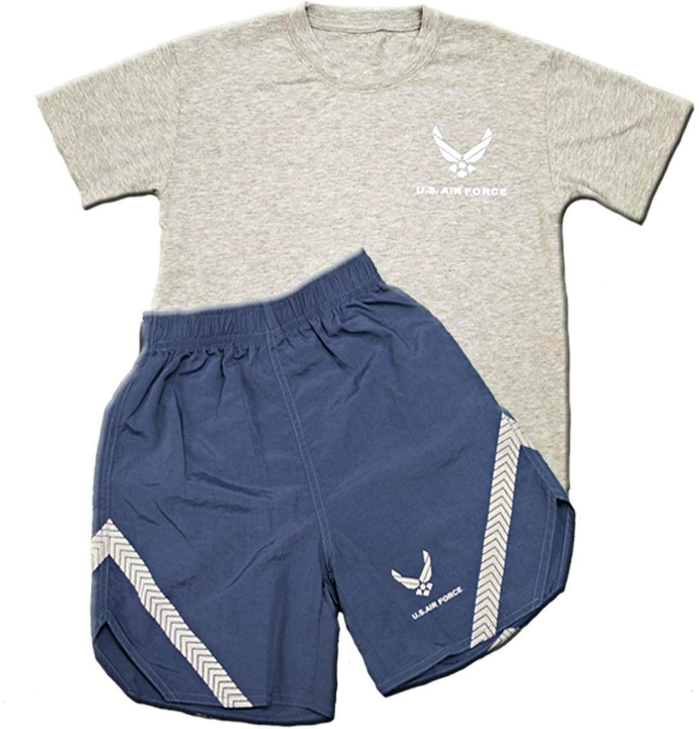
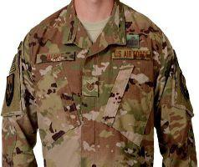

Physical Training Gear, more commonly referred to as “PTGs”.
Worn during every PT session held at your college during the semester.

Operational Camouflage Pattern Uniform, more commonly referred to as “OCPs”.
Worn during AIRS and LLAB when stated as UOD. Rank worn in middle of chest.

Service Dress and blues, worn during AIRS and LLAB when stated as UOD. These two uniform items are worn together. When the jacket is on it becomes service dress and when off it is just called blues. These two uniforms are commonly worn during special occasions such as Ceremonies. Rank worn on shoulders.
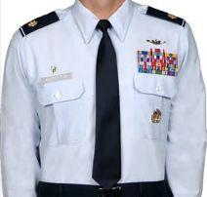

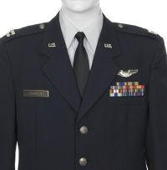

6.1. Uniform Policies.

6.1.1. Uniforms will be kept zipped, snapped, or buttoned, including all pockets.

6.1.2. Cadets in uniform will wear proper headgear at all times when outdoors. Headgear will be removed (1) immediately upon entering a building and (2) while riding a bus or other forms of transportation.

6.1.3. Do not allow anything to protrude from uniform pockets.

6.1.4. Cadets are not authorized to place their hands in their pockets for reasons other than retrieving items.

6.1.5. For further reference, see AFI 36-2903 AFROTC Supplement.

6.2. Males Blues Uniform Standards.

6.2.1. Short Sleeve Blues Shirt. This uniform consists of the trousers, short-sleeve blue shirt, soft shoulder rank, flight cap, black shoes, and the tie is optional. Center the name tag over the right pocket, resting on but not over it. A white v-neck t-shirt is worn underneath this uniform.

6.2.2. Long Sleeve Blues Shirt. This uniform consists of trousers, long-sleeved blue shirt, soft shoulder rank, flight cap, black shoes, and the tie is mandatory. Center the nametag over the right pocket, resting on but not over it. A white v-neck t-shirt is worn underneath this uniform.

6.2.3. Service Dress Uniform. This uniform consists of the service dress coat, trousers, long or short sleeved blues shirt, soft shoulder rank, flight cap, black shoes, and the tie is mandatory. The U.S. lapel insignia is worn with this uniform, one on each collar. The insignia is placed halfway up the seam resting on but not over it and is parallel to the ground as you wear the coat.

6.2.4. Lightweight Blue Jacket. This jacket is worn with the long or short sleeved blues uniform. The rank for the jacket is the metal pin on rank and should be placed on the jacket’s epaulet 1 inch from the outer seam and centered. For CADET AIRMAN rank, the pointed side will face towards the inside, and for CADET OFFICER rank the lines are parallel to the shoulder seem. When worn, jackets must be zipped up at least halfway.

6.2.5. Tie. The tie is mandatory while wearing the long-sleeve blues uniform and the service dress uniform. The tie is tied in a double Windsor knot. The tip of the tie will not extend more than ½ an inch above or below the center of the belt buckle. If the small end of the tie extends further than the large end, then tuck the excess into your pants.

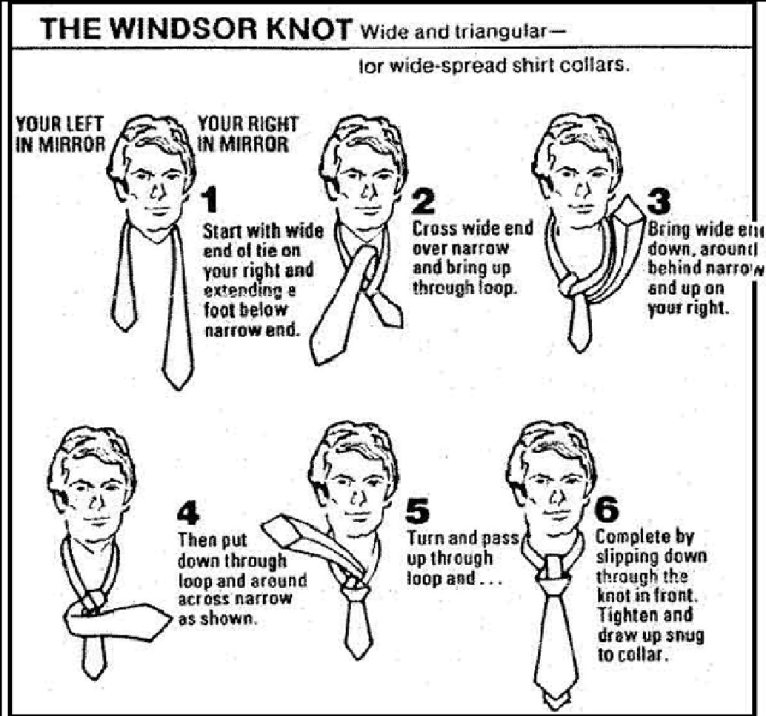

6.2.6. Flight Cap. This is the cap that is worn will all combinations of the blues uniform. It is placed resting on the top of the head with two fingers width between the bridge of the nose and the front of the cap and will not be split on top. The metal rank insignia will be placed on the left side of the cap 1 ½ inches from the front and vertically centered between the bottom of the cap and the top seam, where the silver braid is.

6.2.7. Belt. The belt is blue with a chrome buckle and tip. Sometimes the belt will need to be cut to correctly fit. If this needs to be done ensure that you leave enough extra belt, not to exceed 1 ½ inches. Place the belt on, beginning it on the left side of the pants, so that the tip is facing your left. Once on, ensure that the chrome tip is slightly out of the buckle, aligning the inside edge of the tip with the edge of the buckle.

6.2.8. Shoes. These shoes will be kept polished, worn with black socks, and laced to the top. Laces must be tucked in. All cadets who have not attended field training will wear detachment issued boots and detachment issued low quarters. Cadets may purchase their own boots in regulations but are not permitted to wear patent leather low quarters.

6.2.9. Gloves. Gloves can be worn during inclement weather in the following uniforms only: OCPs, blues service dress, and the blues lightweight jacket.

Short/Long Sleeve Blues Uniform - Male 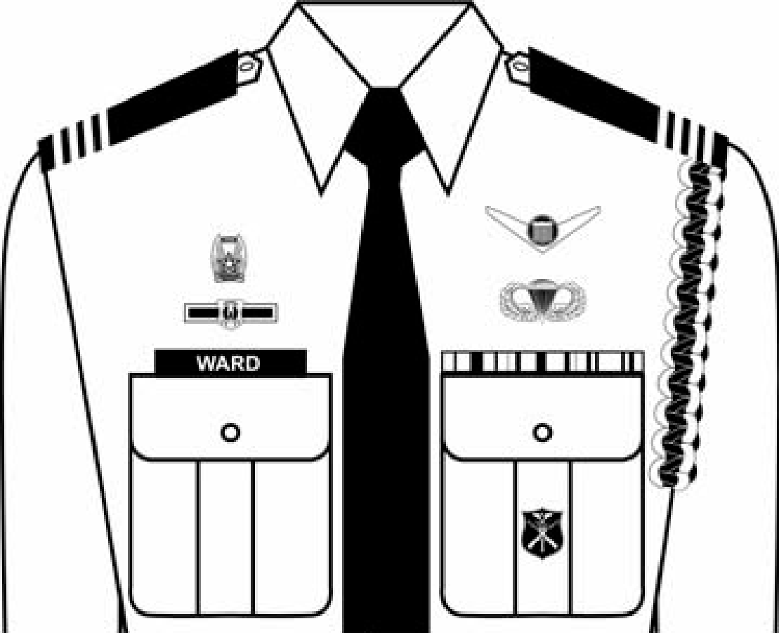

Service Dress Uniform – Male 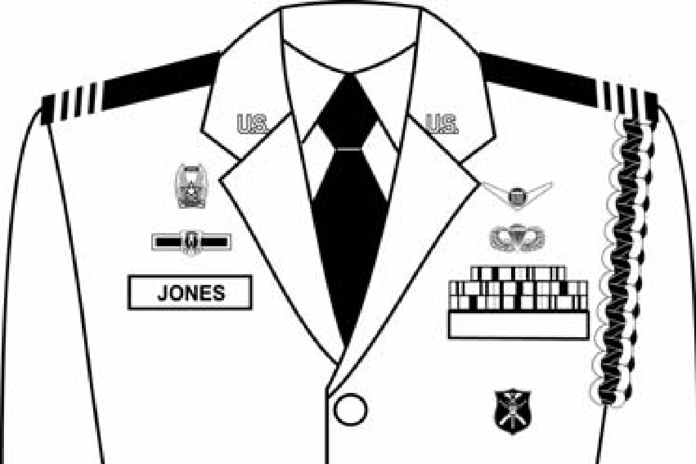

6.3. Female Blues Uniform Standards.

6.3.1. Short Sleeve Blues Shirt. This uniform consists of the trousers or skirt, short-sleeve blue shirt, soft shoulder rank, flight cap, black shoes, and the tie tab is optional. Center name tag on right side of the uniform even with or up to 1 ½ inches above or below the first buttoned button and parallel to the ground. Blouse must be tucked in. Make sure that undergarments are properly tucked in and not visible.

6.3.2. Long Sleeve Blues Blouse. This uniform consists of trousers or skirt, long-sleeved blue shirt, soft shoulder rank, flight cap, black shoes, and the tie is mandatory. Center name tag on right side of the uniform even with or up to 1 ½ inches above or below the first buttoned button and parallel to the ground. Blouse must be tucked in. Make sure that undergarments are properly tucked in and not visible.

6.3.3. Service Dress Uniform. This uniform consists of the service dress coat, trousers or skirt, long or short sleeved blues shirt, soft shoulder rank, flight cap, black shoes, and the tie tab is mandatory. The U.S. lapel insignia will be worn with this uniform, one on each collar. The insignia is placed halfway up the seam resting on but not over it and is parallel to the ground as you wear the coat.

6.3.4. Skirt. The skirt is worn with any blouse or service coat. It is hemmed so that it is no shorter than the top of the kneecap and no longer than the bottom of the knee cap. A good guideline is to ensure that the skirt is at the middle of the knee. It is worn with black, navy, or flesh tone panty hose, and low quarters or black pumps, with a heel no higher than 2 ½ inches.

6.3.5. Lightweight Blues Jacket. This jacket is to be worn with the long or short-sleeved blues uniform. The rank for the jacket is the metal pin on rank and should be placed on the jacket’s epaulet 1 inch from the outer seam and centered. For CADET AIRMAN ranks the pointed side will face towards the inside, and for CADET OFFICER rank the lines are parallel to the shoulder seem.

6.3.6. Tie Tab. The tie is mandatory while wearing the long-sleeve blues uniform and the service dress uniform. The tie tab is positioned so that the two points of the collar are in the long section of the tab and the middle is aligned with the gig line.

6.3.7. Flight Cap. This is the cap that is worn with all combinations of the blues uniform. It is placed resting on the top of the head with two fingers width between the bridge of the nose and the front of the cap. The metal rank insignia is placed on the left side of the cap 1 ½ inches from the front and vertically centered between the bottom of the cap and the top seam, where the silver braid is.

6.3.8. Belt. The belt is blue with a chrome buckle and tip. Sometimes the belt needs to be cut to fit correctly. If this needs to be done ensure you leave enough extra belt, not to exceed 1-½ inches. Place the belt on, beginning it on the right side of the pants, so the tip is facing your right. Once on, ensure the chrome tip is slightly out of the buckle, aligning the inside edge of the tip with the edge of the buckle.

6.3.9. Gloves. Gloves can be worn during inclement weather in the following uniforms only: OCPs, blues service dress, and the blues windbreaker.

Short/Long Sleeve Blues Uniform – Female 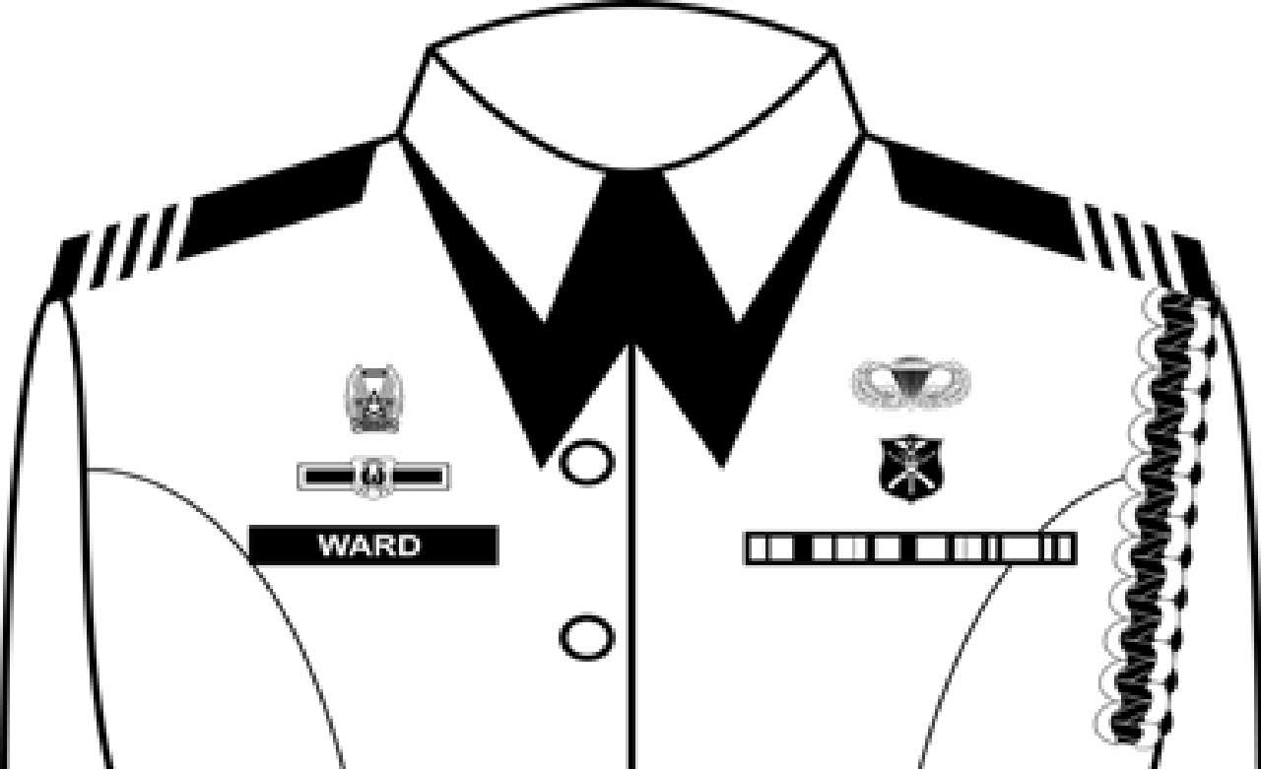

Service Dress Uniform – Female 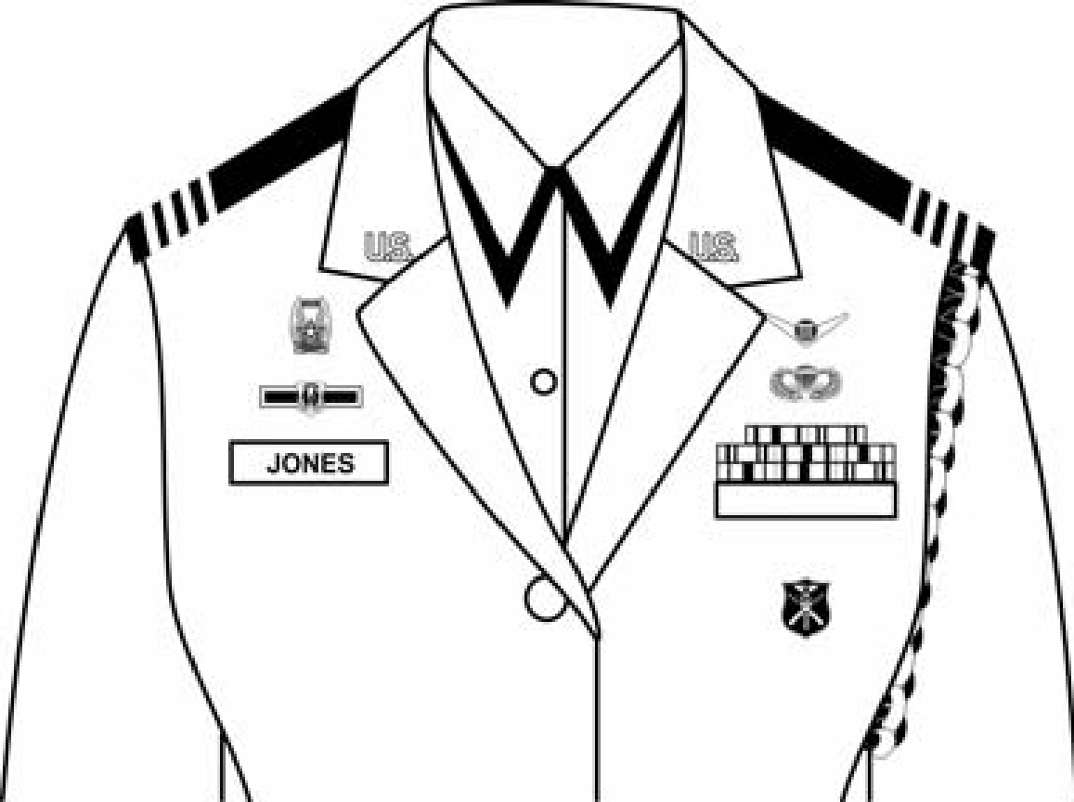

6.4. Male and Female OCP Uniform Standards.

6.4.1. Operational Camouflage Pattern (OCP). This uniform consists of belt, OCP trousers, OCP coat/shirt, T-shirt underneath, socks, Coyote Brown boots, and OCP cap.

6.4.2. OCP Coat (Shirt). Cadets may sew on or use velcro backing for name tape and USAF/USSF tape, which must be spice brown (space blue for USSF) embroidery on the OCP background (. You must use either only sewn on or only velcro nametapes/ranks – you may not mix sewn and velcro nametapes/ranks. Cadet rank will be centered on front velcro patch and pinned; CADET AIRMAN rank will point upward, and CADET OFFICER rank will be centered with horizontal lines parallel to the ground. Patches or badges will not be affixed to the front pockets. The U.S. Flag patch is mandatory and will be subdued in spice brown (full color for USSF) and centered at the top of right sleeve velcro. Organizational unit patch will be subdued in spice brown (full color for USSF) and centered below U.S. Flag. Higher Headquarters patch will be subdued in spice brown (full color for USSF) and centered in the middle of the velcro area on the left sleeve.

6.4.3. T-Shirt. T-Shirt will be Desert Sand, Tan, or Coyote Brown and will be tucked into OCP trousers.

6.4.4. OCP Trouser. The OCP trousers are worn buttoned and with a belt. Pockets will be secured, and items stowed in pockets will not be visible. Cadets may wear the trousers tucked into the top of the boots or bloused using the draw strings at the bottom of the trousers, or commercial blousing devices if the trousers are not tucked into the boots. When bloused, the trousers will not extend below the third eyelet from the top of the boot.

6.4.5. Belt. A one-piece Tan-499 rigger style, nylon, web belt will be worn with OCP trousers. Belt may extend past buckle.

6.4.6. OCP Patrol Cap. The patrol cap will be worn outside at all times, unless in a designated “no hat” area. Cadets will wear the patrol cap straight on the head so that the cap band creates a straight line around the head, parallel to the ground. The patrol cap will fit snugly and comfortably around the largest part of the head without bulging or distortion from the intended shape of the headgear and without excessive gaps. The cap is worn so that no hair is visible on the forehead beneath the cap.

6.4.7. Socks. Socks must be Desert Sand, Tan, DLA-Issued Green socks or Coyote Brown socks.

6.4.8. Boots. Cadets must wear coyote brown detachment issued, or personally purchased, boots. Laces must be tucked into boots, so no laces show.

6.4.9. Cold Weather Accessories. Cold weather accessories will only be worn when wearing authorized outer garments. Coyote Brown or black scarves, earmuffs, watch cap and sage green, black or coyote brown gloves. Coyote brown fleece may be worn.

6.5. Uniform Care.

6.5.1. Cleaning. Uniforms are to be kept clean and serviceable at all times. Each cadet is responsible for cleaning and laundering his/her own uniform. Cleaning must be done so as to not interfere with the wearing of the uniform to classes, LLAB, or other AFROTC activities. Cadets are responsible for the cleanliness and maintenance of their uniforms up to and including commissioning/disenrollment. Short and Long Sleeve shirts can be machine washed. All other Service Dress uniforms must be dry-cleaned. OCPs are machine washable and may be dry cleaned. Uniforms are to be kept lint-free. Use a lint brush or masking tape to remove lint. Hang the uniform in a plastic bag to prevent collection of lint.

6.5.2. Pressing. Uniforms should be neatly pressed to present a military image at all times. Military creases are not allowed. When pressing at item, put a cloth or handkerchief over the section being pressed to prevent a shine along the seams and creases. Hang the uniform on a suit hanger to prevent wrinkling.

6.5.3. Ironing. Avoid ironing multiple creases in the same area (“railroad tracks”.) If using starch, dampen the area and wait for starch to soak into the fabric before ironing. When using starch, keep the iron moving across the fabric to avoid starch marks.

6.5.4. Shining Low Quarters. One pair of shoes is issued to each cadet entering the program. Shoes cannot be returned after issue; they become cadet property. Shoes are to be kept shined to a high shine at all times. There are many different techniques for shoe shining. The minimum materials required are black shoe polish, some water, and a rag (or cotton balls). Hot water works best, because it melts the polish evenly over the shoe, giving a glossier shine.

6.5. Awards and Decorations.

6.5.1. Ribbons earned in AFROTC, or medals earned on Active Duty for valor or gallantry can be worn with any combination of the blues uniform. The ribbons are worn in rows of three and centered above the left pocket for males and centered on the right and even with the bottom of the nametag for females. Different ribbons have priority over others and must be placed in a specific order in the row. For further instruction on this see the ribbon section of the AFROTCI 36-2008 or see your flight commander for help. Reference AFI 36-2903 & AFROTCI 36-2008. Do not mix AFROTC and Active Duty medals together on a blues uniform.

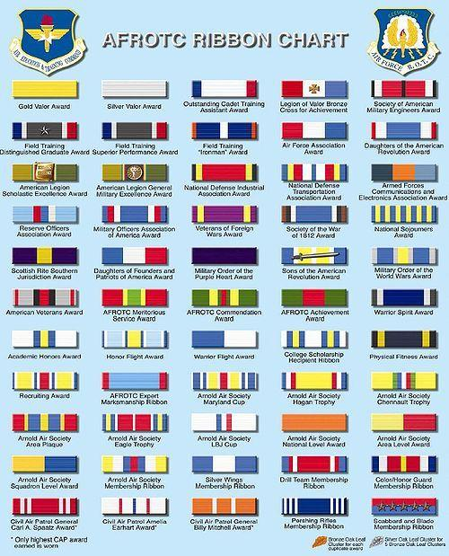

6.6. Uniform Accessories.

6.6.1. Earrings. Earrings are worn by female cadets if they are small and conservative. They must be white pearl, gold, silver, black, or diamond, and be spherical in shape (studs). Only one matching pair are worn at any time. Males will not wear earrings in uniform, in or around the corps area, or to any corps supported functions.

6.6.2. Watches. Watches must be conservative and professional in color and size. Cadets are recommended to wear a digital watch with the OCP in order to have a stopwatch during LLAB.

6.6.3. Rings. You may wear up to three rings in uniform: two on one hand and one on the other. They must be conservative and professional.

6.6.4. Bracelets. You may wear one bracelet that is no wider than 1/2 inch, is conservative in color, and it must be worn on the opposite side as the watch. Anklets are not authorized.

6.6.5. Necklaces. If worn, it must be concealed.

6.6.6. Sunglasses. Sunglasses must be free from ornamentation, conservative, cannot have mirrored lenses, and cannot be worn while in formation. Frames may be black or brown material or gold/silver wire. Conservative wrap-around style sunglasses are authorized. Small, conservative ornamentation on nonprescription sunglasses and eyeglasses is authorized. Brand name glasses may be worn with a small, conservative logo on the frames of lens. If worn, the logo must be same color as frames or lens. Sunglasses will not be worn around the neck, on the top of the head, or hanging from the uniform in any way.

6.6.7. Backpacks. Black backpacks may be worn with any uniform combination. Only solid color black backpacks will be worn with blue uniform combinations. OCP patterned back packs, Tan and Coyote Brown may be worn with the OCP. Small logos are authorized. Airmen may wear either a sling style backpack or two straps back pack. Sling back packs will be worn across the chest, if carried on shoulder wear on the left shoulder. Two-strap back packs will be worn on the left shoulder or both shoulders (not to interfere with rendering the proper salute). Back packs will not have ornamentation, a high-gloss, designs, or hanging/dangling objects. Small gold or silver clasp authorized, but chains are not authorized.

6.6.8. Umbrellas. Umbrellas will be plain, solid colored black, and carried in the left hand.

6.6.9. Tattoos. Tattoos/brands/body markings will not be on the hands (except one ring tattoo on one finger on one hand), head, neck (anything visible above the open collar uniform), face, tongue, lips, eyes, and scalp. Tattoos are authorized on the chest and back (below the open collar uniform), arms, legs, and a ring tattoo to one finger on one hand. Ring tattoos are limited to a single band of no more than 3/8 of an inch in width, below the knuckle and above the finger joint. Tattooing for cosmetic purposes is authorized when directed by licensed, qualified medical personnel to correct a medical condition, illness or injury for both men and women.

6.6.10. Body Piercing/Ornamentation. In uniform on or off a military installation: With the exception of earrings for women, all members are prohibited from attaching, affixing, or displaying objects, articles, jewelry or ornamentation to or through the ear, nose, tongue, eyebrows, lips, or any exposed body part (includes visible through the uniform).

6.6.11. Body Alteration/Modification. Intentional alterations and/or modifications to a member’s body that result in a visible, physical effect that disfigures, deforms or otherwise detracts from a professional military image are prohibited.

6.3. Grooming Standards. Refer to AFI36-2903.

6.3.1. Male Grooming Standards.

Appearance: Tapered appearance on both sides and the back of the head, both with and without headgear
Bulk of Hair: Tapered cut, not exceeding 2”
Sideburns cannot touch ears, must be straight and even, cannot extend past bottom of ear opening
Part: May have one (cut, clipped or shaved) front to back, straight-line part, not slanted or curved, on either side of their head, above the temple.
Mustaches: Conservative, must not extend past the limits of the upper lip
Beards: Not authorized, exceptions for medical exemptions
Cosmetics: Unauthorized for male airmen

6.3.2. Female Grooming Standards.

Hair must be a natural, one-tone color
Bulk may not exceed 4”
Hair accessories must be black or match hair color.
One or two braids or a single ponytail may be worn down the member’s back with bulk not exceeding the width of the head and length not extending below a horizontal line running between the top of each sleeve inseam at the under arm through the shoulder blades.
Bangs, or sideswiped hair, may touch eyebrows but will not touch or cover eyes.
Physical Training Gear: long hair will be secured but may have loose ends and may extend below a horizontal line running between the top of each sleeve inseam at the under arm through the shoulder blades
Nails and cosmetics must be a conservative, neutral color.
Necklaces will not be visible at any time.
Earrings may be worn in lowest lobe piercing (gold/silver balls, diamonds, pearls authorized).

7. Physical Fitness

7.1. Importance of Physical Fitness. Physical fitness is very important for all military personnel. As an Air Force officer, you need to be physically fit to endure the rigors and stress of your job both in battle and in peace time. Being physically fit helps you make sounds decisions and performs under pressure. We all, as military personnel, must be physically fit and prepared to do battle and defend our country and constitution. It is also important to be physically fit so that we maintain a professional, healthy, representation of the detachment, AFROTC, and the Air Force.

7.2. Height and Weight Standards. Cadets must stay within a healthy weight limit, as indicated on the weight standards chart in this cadet guide. If the cadet’s weight is over the maximum allowable weight (MAW) for their particular height, then the cadet will be measured to determine body fat percentage. If the cadet's body fat content is above the limit, that cadet is not allowed to wear the Air Force uniform until within standards. The cadet will also be considered for possible release from Air Force ROTC. A cadet who fails to meet standards may lose his/her scholarship and/or be released from the AFROTC program. If you are a contracted cadet and you fail weight or body fat standards, you will be placed on the weight management program.

7.3. Physical Fitness Assessment (PFA). The Physical Fitness Assessment is a test administered to ensure that cadets maintain a good fitness level. The PFA is completed at least once each semester by the entire cadet wing; the test is composed of three events. These events are sit-ups, pushups and the 1.5-mile run. Cadets must pass the PFA with a minimum score of 75 or greater to meet all individual component minimums. Failure to meet even one component will result in an overall failure.

7.4. Testing Information. The PFA will be conducted IAW AFI 36-2905.

7.4.1. Push-ups. Cadets have one minute to perform as many correct push-ups as they are able. The counter will count the correct number of push-ups aloud. The counter will not count incorrect push-ups. The counter will tell the cadet what they are doing wrong and will repeat the last number of correct push-ups until they correct the error. The total number of correct push-ups in one minute is recorded as the score.

7.4.1.1. Starting Position. The member will begin in the starting position with hands slightly wider than shoulder width apart, palms or fists on the floor with arms fully extended and the body in a straight line from head to heel. The feet may be no more than 12 inches apart. The member may rest in the up position only. The member may remove their hands or feet from the floor, or bridge or bow their back, but only in the up/rest position. The body should maintain a rigid form from head to heel. The feet may not be supported or braced (e.g., no crossing of the feet).

7.4.1.2. Complete Push-up. From the starting position (elbows extended), the member will lower the body to the ground until the upper arm is at least parallel to the floor (elbow bent at least 90 degrees or less) before pushing back up to the starting position (the chest may touch but not rest on or bounce off the floor). The member completes one full push-up after returning to the starting position with elbows fully extended. It is important to ensure that the form of the push-up is correct. Do not allow the body to bow at the waist as cadets tire. The body must remain rigid during the assessment (the back must remain straight unless resting). Incorrect push-ups (e.g., member does not lower body until upper arm is at least parallel to the floor, member does not fully extend elbows when returning to the starting position, body bows at the waist, etc.) will not be counted. If an incorrect push-up is performed, the counter will repeat the number of the last correct push-up and explain what is being done incorrectly. Cadets may rest in the up position only. If cadets rest in the down position with their body on the ground, the push-up component of the test will be terminated.

7.4.1.3. Completion of Exercise. 1-minute time limit expires; cadet rests in the down position or with any body part resting on the ground other than hands and feet (knees, elbows, etc.).

7.4.2. Sit-ups. Cadets have one minute to perform as many correct sit-ups as possible. The counter will count the correct number of sit-ups aloud. The counter will not count incorrect sit-ups. The counter will tell the cadet what they are doing wrong and will repeat the last number of correct sit-ups until they correct the error. The total number of correct sit-ups in one minute is recorded as the score.

7.4.2.1. Starting Position. Cadets will lie face up on the floor/mat. In the starting position, the feet may extend off the mat, but the buttocks, shoulders, and head must not extend beyond the mat. The knees will be bent at a 90-degree angle (throughout the assessment), with the feet or heels in contact with the floor at all times. The arms will be crossed over the chest with the hands/fingers on the shoulders or resting on the upper chest.

7.4.2.2. Foot Hold. The heels must remain anchored to the floor throughout the assessment. Cadets may request to have their feet held down. The “holder” may use their hands or put their knees on the cadet’s feet, but the holder may not anchor legs by holding onto the calves or standing on the feet during the assessment. The holder will use enough force to keep the feet/ankles from rising while the sit-ups are being accomplished.

7.4.2.3. Complete Sit-up. A complete sit-up is accomplished when the upper torso is raised off the floor/mat, the elbows touch the knees or thighs, and the upper torso is lowered back to the floor/mat until the shoulder blades touch the floor/mat. Elbows must touch the knees or thighs at the top of the sit-up, and the shoulder blades must touch the floor/mat at the bottom of the sit-up. Any part of the hands/fingers must remain in contact with the shoulders/upper chest at all times. Incorrect sit-ups (i.e., elbows do not touch the knees or thighs at the top of the sit-up, shoulder blades do not touch the floor/mat at the bottom of the sit-up, hands/fingers lift completely off the shoulders/upper chest, etc.) will not be counted. If an incorrect sit-up is performed, the counter will repeat the number of the last correct sit-up and explain what is being done incorrectly. Cadets may only rest in the up position. If cadets rest in the down position or hold onto the knees/legs while in the up position, the sit-up component of the assessment will be terminated.

7.4.2.4. Completion of Exercise. 1-minute time limit expires; cadet rests in the down position or holds onto their knees/legs while in the up position

7.4.3. 1.5-Mile Run.

7.4.3.1. Acceptable. Walking at any time or momentarily stopping to re-fasted shoelace(s) during the run, provided cadets remain within the lateral limits of the running surface; signaling current lap count verbally or using fingers; wearing a watch; using personal earbuds and cell phone if approved by POC present; walking for one lap on the outside of the track to cool down after completing the 1.5-mile run.

7.4.3.2. Unacceptable. Crossing an inside barrier (if present); deliberate physical contact with another runner or observer, regardless if the contact occurs on or off the running surface.

7.4.3.3. Completion of Exercise. Crossing the finish line; failure to cross the finish line (regardless of reason) results in a score of zero for the event.

7.4.3.4. Observers. Must remain off the running surface (e.g., no pacers are allowed).

7.4.4. USAF Fitness Scoring for Males < 25 Years of Age.

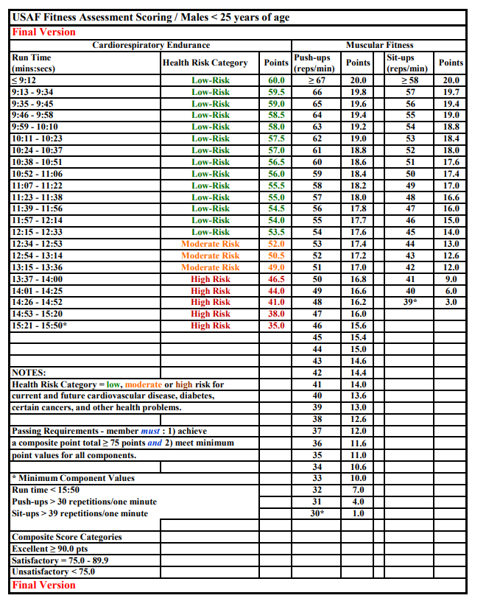

7.4.5. USAF Fitness Scoring for Females < 25 Years of Age.

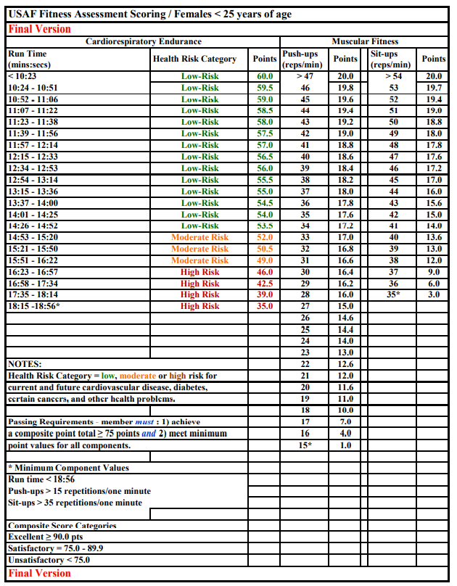

8. Basic Knowledge

8.1. Chain of Command.

8.1.1. Importance. The purpose and importance of the chain of command is to solve problems at the lowest level of command. Essentially, there are two key links in the chain of command which closely affect you. The first is between you and your superior. This link provides you with your tasking and your superior with feedback on your performance. The second link is between you and those cadets who report directly to you (i.e., you supervise them and provide them feedback on their performance). This link provides them with their tasking and provides you with feedback. Follow the chain of command to the greatest extent possible in all your official dealings. If you have a task that you know will ultimately be done by a cadet two links down the chain, give the tasking to the cadet's superior (who works directly for you) and let it flow down from there.

8.1.2. Air Force Chain of Command.

Commander in Chief: _____________________________________________________

Secretary of Defense: _____________________________________________________

Secretary of the Air Force: __________________________________________________

Chief of Staff of the Air Force: _______________________________________________

Chief of Space Operations: _________________________________________________

AETC Commander: _______________________________________________________

AU Commander: __________________________________________________________

Holm Center Commander: __________________________________________________

AFROTC Commander: _____________________________________________________

SE Regional Commander: ___________________________________________________

Chief Master Sergeant of the Air Force: ________________________________________

Space Force Senior Enlisted Advisor: __________________________________________

8.1.3. Detachment 890 Chain of Command.

Detachment 890 Commander: ________________________________________________

Operations Officer: _________________________________________________________

Operations Flight Commander - UVA/JMU: ______________________________________

Operations Flight Commander - LU: ____________________________________________

Education Officer: ___________________________________________________________

Recruiting Officer: ___________________________________________________________

Non-Commissioned Officer in Charge: ___________________________________________

Non-Commissioned Officer in Charge of Personnel: _________________________________

Non-Commissioned Officer in Charge of Administration: _____________________________

Associate Professor of Air Science: ______________________________________________
8.1.4. Wing Cadet Chain of Command.

Wing Commander: _________________________________________________________

Vice Wing Commander: _____________________________________________________

Inspector General: __________________________________________________________

Operations Group Commander: _______________________________________________

Mission Support Group Commander: ___________________________________________

Force Support Group Commander: _____________________________________________

8.2. AFROTC Knowledge.

8.2.1. Air Force Core Values. Integrity First, Service Before Self, Excellence in All We Do

8.2.2. Oath of Office. I, FULL NAME, having been appointed a Second Lieutenant, in the United States Air Force, do solemnly swear (or affirm) that I will support and defend the Constitution of the United States against all enemies, foreign and domestic, that I will bear true faith and allegiance to the same; that I take this obligation freely, without any mental reservation or purpose of evasion, and that I will well and faithfully discharge the duties of the office upon which I am about to enter. SO HELP ME GOD.

8.2.3. AFROTC Honor Code. We will not lie, steal, or cheat, nor tolerate among us anyone who does.

8.2.4. Phonetic Alphabet.

A – Alpha B – Bravo C – Charlie D – Delta E – Echo F – Foxtrot
G – Golf H – Hotel I – India J – Juliet K – Kilo L – Lima
M – Mike N – November O – Oscar P – Papa Q – Quebec R – Romeo
S – Sierra T – Tango U – Uniform V – Victor W – Whiskey X – X-Ray
Y – Yankee Z – Zulu

8.2.5. Air Force Song.

Off we go into the wild blue yonder,
Climbing high into the sun;
Here they come zooming to meet our thunder,
At ‘em now, Give ‘em the gun!
Down we dive, spouting our flame from under,
Off with one helluva roar!
We live in fame or go down in flame. Hey!
Nothing‘ll stop the U.S. Air Force!

Brilliant minds fashioned a crate of thunder,
Sent it high into the blue;
Valiant hands blasted the world asunder;
How they lived God only knew!
Boundless souls dreaming of skies to conquer
Gave us wings, ever to soar!
With scouts before and bombers galore. Hey!
Nothing‘ll stop the U.S. Air Force!

Here‘s a toast to the host
Of those who love the vastness of the sky,
To a friend we send a message of the brave who serve on high.
We drink to those who gave their all of old,
Then down we roar to score the rainbow‘s pot of gold.
A toast to the host of those we boast, the U.S. Air Force!

Off we go into the wild sky yonder,
Keep the wings level and true;
If you‘d live to be a gray-haired wonder
Keep the nose out of the blue!
Flying to fight, guarding the nation‘s border,
We‘ll be there, followed by more!
In echelon we carry on. Hey!
Nothing‘ll stop the U.S. Air Force!

8.2.6. Military Code of Conduct.

I. I am an American, fighting in the forces which guard my country and our way of life. I am prepared to give my life in their defense.

II. I will never surrender of my own free will. If in command, I will never surrender the members of my command while they still have the means to resist.

III. If I am captured, I will continue to resist by all means available. I will make every effort to escape and aid others to escape. I will accept neither parole nor special favors from the enemy.

IV. If I become a prisoner of war, I will keep faith with my fellow prisoners. I will give no information nor take part in any action which might be harmful to my comrades. If I am senior I will take command. If not I will obey the lawful orders of those appointed over me and back them up in every way.

V. When questioned, should I become a prisoner of war, I am required to give name, rank, service number, and date of birth. I will evade answering further questions to the utmost of my ability. I will make no oral or written statements disloyal to my country and its allies or harmful to their cause.

VI. I will never forget that I am an American, fighting for freedom, responsible for my actions, and dedicated to the principles which made my country free. I will trust in my God and in the United States of America.

8.2.7. The Airman’s Creed.

I AM AN AMERICAN AIRMAN.
I AM A WARRIOR
I HAVE ANSWERED MY NATION’S CALL.

I AM AN AMERICAN AIRMAN.
MY MISSION IS TO FLY, FIGHT, AND WIN.
I AM FAITHFUL TO A PROUD HERITAGE,
A TRADITION OF HONOR,
AND A LEGACY OF VALOR.

I AM AN AMERICAN AIRMAN.
GUARDIAN OF FREEDOM AND JUSTICE,
MY NATION’S SWORD AND SHIELD,
ITS SENTRY AND AVENGER.
I DEFEND MY COUNTRY WITH MY LIFE.

I AM AN AMERICAN AIRMAN:
WINGMAN, LEADER, WARRIOR.
I WILL NEVER LEAVE AN AIRMAN BEHIND,
I WILL NEVER FALTER,
AND I WILL NOT FAIL.

8.2.8. Air Force Enlisted Ranks.

 | Air Force Enlisted Rank and Insignia
 | Rank | Title | Abbreviation | Insignia
 | E-1 | Airmen Basic | AB | N/A
 | E-2 | Airmen | Amn | 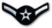
 | E-3 | Airman First Class | A1C | 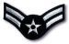
 | E-4 | Senior Airmen | SrA | 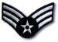
 | E-5 | Staff Sergeant | SSgt | 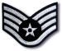
 | E-6 | Technical Sergeant | TSgt | 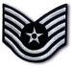
 | E-7 | Master Sergeant | MSgt | 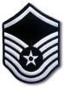
 | E-8 | Senior Master Sergeant | SMSgt | 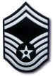
 | E-9 | Chief Master Sergeant | CMSgt | 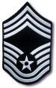
 | E-9 | Chief Master Sergeant of the Air Force | CMSAF

8.2.9. Air Force Officer Ranks.

 | Air Force Officer Rank and Insignia
 | Rank | Title | Abbreviation | Insignia
 | O-1 | SECOND LIEUTENANT | 2d Lt
 | O-2 | FIRST LIEUTENANT | 1st Lt
 | O-3 | CAPTAIN | Capt
 | O-4 | MAJOR | Maj
 | O-5 | LIEUTENANT COLONEL | Lt Col
 | O-6 | COLONEL | Col
 | O-7 | BRIGADIER GENERAL | Brig Gen
 | O-8 | MAJOR GENERAL | Maj Gen
 | O-9 | LIEUTENANT GENERAL | Lt Gen
 | O-10 | GENERAL | Gen

8.2.10. Air Force Vision. The U.S. Air Force is the world’s preeminent force in air, space and cyberspace. We maintain that distinction by maintaining our objective of global vigilance, reach and power and remaining true to our vision statement: The World’s Greatest Air Force—Powered by Airmen, Fueled by Innovation. Through shared values, key capabilities and upholding our Airman’s Creed, we continue to achieve our mission and aim high in all we do.

8.2.11. Air Force Birthday. 18 September 1947.

8.2.12. Space Force Birthday. 20 December 2019.

8.2.13. Air Force and Space Force Mission. Fly, Fight and Win in Air, Space and Cyberspace.

8.2.14. AFROTC Mission. Develop leaders of character for tomorrow’s Air Force and Space Force.
8.2.15. Important Quotes.

“The more you sweat in peace, the less you bleed in war.”
- General Norman Schwarzkopf

“Duty then is the sublimest word in the English language. You should do your duty in all things. You can never do more. You should never wish to do less.”
- General Robert E. Lee, CSA

“The American people rightly look to their military leaders to be not only skilled in the technical aspects of the profession of arms, but to be men of integrity.”
- General Joseph L. Collins, USA

“Leadership is intangible; therefore no weapon ever designed can replace it.”
- General Omar N. Bradley, USA

“If our air forces are never used, they have achieved their finest goal.”
- General Nathan F. Twining, USA

“If I didn’t have air supremacy, I wouldn’t be here.”
- General Dwight D. Eisenhower, USA

”In every battle, there comes a time when both sides consider themselves beaten; then he who continues the attack wins.”
- General Ulysses S. Grant, USA

“War is an ugly thing, but not the ugliest of things. The decayed and degraded state of moral and patriotic feeling, which thinks that nothing is worth war, is much worse. The person, who has nothing for which he is willing to fight, nothing which is more important than his own personal safety, is a miserable creature and has no chance of being free unless made and kept so by the exertions of better men than himself.”
- John Stuart Mill

“Integrity is the fundamental premise for military service in a free society. Without integrity, the moral pillars of our military strength, public trust, and self-respect are lost.”
- General Charles A. Gabriel, Chief of Staff, USAF

“It is the soldier, not the reporter, who has given us the freedom of the press. It is the soldier, not the poet, who has given us the freedom of speech. It is the soldier, not the campus organizer, who has given us the freedom to demonstrate. It is the soldier who salutes the flag, who serves beneath the flag, and whose coffin is draped by the flag, who allows the protestor to burn the flag.”
- Father Denis E. O’Brien, Sergeant, USMC

“War, once declared, must be waged offensively, aggressively. The enemy must not be fended off; but smitten down. You may then spare him every exaction, relinquish every gain, but ‘til then he must be struck incessantly and remorselessly.”
- Alfred Thayer Mahan

“The power of excellence is overwhelming. It is always in demand, and nobody cares about its color.”
- General Daniel S. “Chappie” James, USAF

“Gentlemen, clear the smoke and continue the honor of those before you.”
- Colonel Bud Day

“Gender, race, religion, none of that matters. What matters is how you perform.”
- Brig Gen Jeannie M. Leavitt, USAF

“There’s no quitting. I can’t have quit in me. There was never an option to stop and quit.”
- Major Lisa Jaster, USA

“Victory smiles upon those who anticipate the changes in the character of war, not upon those who wait to adapt themselves until after the changes occur.”
- Italian Air Marshall Guilio Douhet

8.2.16. Air Force Aircraft.

Fighters.

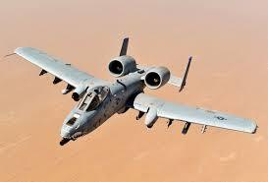 | A-10 Thunderbolt II  (Warthog)  Primary Function: Air-to-ground, Close air support | Speed: 439 mph (combat) | Range: 288 miles with 9500 lbs of weapons and 1.7 hour loiter time | Armament:  One 30mm GAU-8A gun and up to 16,000 lbs of ordnance | Crew: 1
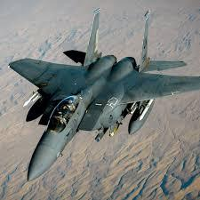 | F-15 Eagle/Strike Eagle  Primary Function: Air Superiority Fighter | Speed: Mach 2.5+ | Range: 3,450 miles with conformal fuel tanks | Armament:  One 20mm multi-barrel gun, 4 sidewinder and 4 sparrow missiles | Crew: 2 (2 E model)
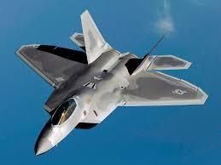 | F-22 Raptor  Primary Function: Air Dominance Fighter | Speed: Mach 2+ | Range: 1724 miles unrefueled | Armament: One M61 cannon, six AIM 120, 2 AIM 9 or 2 1000-lb JDAM, 2 AIM 9 and 2 AIM 120c | Crew: 1 (2 B model)
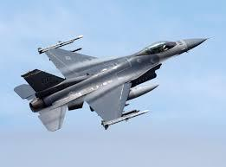 | F-16 Falcon  Primary Function: Multi-role Fighter | Speed: Mach 2.05 | Range: 2,400 miles | Armament: One M-61A1 20mm multi-barrel cannon; 6 air-to-air missiles, air-to-surface munitions | Crew:  F-16 C, 1; F-16D, 1 or 2

Bombers.

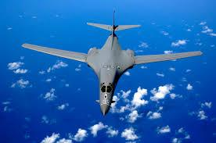 | B-1B Lancer  Primary Function: Multi-role, long range, strategic heavy bomber | Speed: Supersonic-High subsonic for low altitude penetration | Range: Interconti-nental, unrefueled | Armament:  Nuclear (Short-range attack missiles, gravity weapons) and payloads | Crew:  4
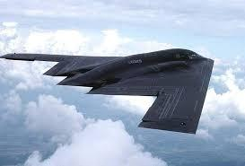 | B-2 Spirit  Primary Function: Multi-role, strategic bomber | Speed: High subsonic | Range: Interconti-nental, unrefueled | Armament: Nuclear (Short-range attack missiles, gravity weapons) and payloads | Crew:  2 with space for 3
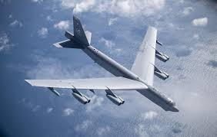 | B-52 Stratofortress  Primary Function: Strategic Heavy Bomber | Speed: 650 mph maximum | Range: 7,500 miles unrefueled | Armament: 70 tons mixed ordnances, short-range attack missiles, bombs, mines | Crew: 5

Cargo/Special Duty.

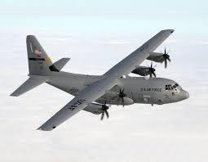 | C-130 Hercules  Primary Function: Troop and Cargo Airlift | Speed: 374 mph | Range: 2,354 miles unrefueled with maximum payload | Crew: 5
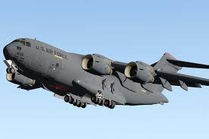 | C-17 Globemaster III  Primary Function: Strategic and Tactical cargo Airlift | Speed: 450 mph | Range: 2,400 miles unrefueled with 160,000 payload | Crew: 2 flight crew plus a load-master
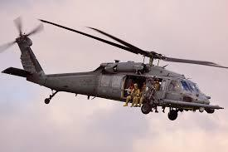 | H-60 Pavehawk  Primary Function: Combat Search and Rescue (CSAR) | Speed: 173 mph | Range: 373 miles; 508 miles with external tanks; unlimited mileage with refuel | Crew: 4
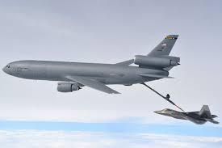 | KC-10 Extender  Primary Function: Aerial Refueling | Speed: Greater than 530 mph at 30,000 feet | Range: Nearly 4,400 miles with 170,000 lbs of fuel | Crew: 4
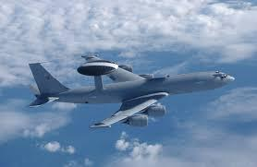 | E-3 Sentry (AWACS)  Primary Function: Airborne surveillance, command, control, and communications | Speed: 360 mph | Range: Greater than 8 hours refueled | Crew: 22, including 18 mission specialists

8.3. Active Duty Information.

8.3.1. Officer Air Force Specialty Codes.

PILOT UTILIZATION FIELD: 11BX – 11UX (10)

COMBAT SYSTEMS OFFICER UTILIZATION FIELD: 12BX – 12UX (10)

SPACE, NUCLEAR AND MISSILE OPERAITIONS, & COMMAND AND CONTROLE (C2) UTILIZATION FIELD: 13AX – 13SX (8)

INFORMATION OPERATIONS UTILIZATION FIELD: 14FX

INTELLIGENCE UTILIZATION FIELD: 14NX

WEATHER UTILIZATION FIELD: 15WX

OPERATIONS SUPPORT UTILIZATION FIELD: 16FX – 16RX (4)

CYBER OPERATIONS UTILIZATION FIELD: 17C – 17SX (3)

REMOTELY PILOTED AIRCRAFT PILOT UTILIZATION FIELD: 18AX – 18SX (5)

LOGISTICS CAREER AREA: 20C

LOGISTICS UTILIZATION FIELD: 21AX – 21RX (3)

SUPPORT CAREER AREA: 30C

SECURITY FORCES UTILIZATION FIELD: 31PX

CIVIL ENGINEER UTILIZATION FIELD: 32EX

PUBLIC AFFAIRS UTILIZATION FIELD: 35BX – 35PX (2)

FORCE SUPPORT OFFICER UTILIZATION FIELD: 38FX

MEDICAL CAREER AREA: 40C

BIOMEDICAL CLINICIAN UTILIZATION FIELD: 42BX – 42TX (8)

PHYSICIAN UTILIZATION FIELD: 44A – 44ZX (19)

SURGERY UTILIZATION FIELD: 45AX – 45UX (8)

NURSE UTILIZATION FIELD: 46AX – 46YX (6)

DENTAL UTILIZATION FIELD: 47BX – 47SX (8)

AEROSPACE MEDICINE UTILIZATION FIELD: 48AX – 48VX (4)

LAW UTILIZATION FIELD: 51JX

CHAPLAIN UTILIZATION FIELD: 52RX

ACQUISITION AND FINANCIAL MANAGEMENT CAREER AREA: 60C

SCIENTIFIC UTILIZATION FIELD: 61AX – 61DX (3)

DEVELOPMENTAL ENGINEERING UTILIZATION FIELD: 62EX – 62SX (2)

ACQUISITION UTILIZATION FIELD: 63AX – 63SX (3)
CONTRACTING UTILIZATION FIELD: 64PX

FINANCE UTILIZATION FIELD: 63FX – 65W (2)

SPECIAL INVESTIGATIONS CAREER AREA: 71SX

SPECIAL DUTY IDENTIFIERS (SDI): COMMANDER, CADET SQUADRON, USAF ACADEMY

TRAINING COMMANDER, OFFICER TRAINING SCHOOL: 81TX

82AX ACADEMIC PROGRAM MANAGER: 82IX – 88A (9)

REPORTING IDENTIFIERS: 90G0 – 99G0 (34)

For further reference, see https://www.af.mil/About-Us/Fact-Sheets/Display/Article/104484/officer-afsc-classifications/.

8.3.2. Stateside Air Force Bases

Maxwell-Gunter AFB, AB Davis-Monthan AFB, AZ
Luke AFB, AZ
Little Rock AFB, AR
Beale AFB, CA
Edwards AFB, CA
Los Angeles AFB, CA
March ARB, CA
Travis AFB, CA
Vandenberg AFB, CA
Buckley AFB, CO
Peterson AFB, CO
Schriever AFB, CO
U.S. Air Force Academy, CO
Dover AFB, DE
Joint Base Anacostia-Bolling, D.C.
Eglin, AFB, FL
Hurlburt Field, FL
MacDill AFB, FL
Patrick AFB, FL
Tyndall AFB, FL
Dobbins ARB, GA
Moody AFB, GA
Robins AFB, GA
Mountain Home AFB, ID
Scott AFB, IL
Grissom ARB, IN
McConnell AFB, KS
Barksdale AFB, LA
Joint Base Andrews-NAF Washington, MD
Hanscom AFB, MA
Westover ARB, MA
Minneapolis-St. Paul ARB, MN
Columbus AFB, MS
Keesler AFB, MS
Whiteman AFB, MO
Malmstrom AFB, MT
Offutt AFB, NE
Creech AFB, NV
Nellis AFB, NV
Pease ANGB, NH
Joint Base McGuire-Dix-Lakehurst, NJ
Cannon AFB, NM
Holloman AFB, NM
Kirtland AFB, NM
Pope AFB, NC
Seymour Johnson AFB, NC
Grand Forks AFB, ND
Minot AFB, ND Wright-Patterson AFB, OH
Youngstown ARS, OH
Altus AFB, OK
Tinker AFB, OK
Vance AFB, OK
Pittsburgh IAP ARS, PA
Joint Base Charleston, SC
Shaw AFB, SC
Ellsworth AFB, SD
Arnold AFB, TN
Brooks City-Base, TX
Dyess AFB, TX
Goodfellow AFB, TX
Lackland AFB, TX
Laughlin AFB, TX
Randolph AFB, TX
Sheppard AFB, TX
Hill AFB, UT
Joint Base Langley-Eustis, VA
Fairchild AFB, WA
JBLM-McChord Field, WA
F.E. Warren AFB, WY

8.3.3. Overseas Air Force Bases.

Eilson AFB, AK
Joint Base Elmendorf-Richardson, AK
Joint Base Pearl Harbor Hickam, HI
Geilenkirchen NATO Air Base, Germany
Ramstein AB, Germany
Spangdahlem AB, Germany
Andersen AFB, Guam
Papa Air Base, Hungary
Aviano Air Base, Italy
Ghedi Air Base, Italy
Kadena AB, Japan
Misawa AB, Japan
Yokota AB, Japan
Kunsan AB, South Korea
Osan Air Base, South Korea
Stavanger, Norway
Lajes Field, Portugal
Morón AB, Spain
Incirlik AB, Turkey
Izmir AS, Turkey
Office of Defense Cooperation, Turkey
RAF Alconbury, RAF Molesworth, RAF Upwood, U.K.
RAF Croughton, RAF Fairford, U.K.
RAF Lakenheath, U.K.
RAF Menwith Hill, U.K.
RAF Mildenhall, U.K.

8.3.4. Space Force Bases.

Los Angeles SFB, CA
Vandenberg AFB, CA
Buckley AFB, CO
Peterson Schriver Garrison, CO
Patrick SFB, FL

9. Reporting Civil Involvements and Medical Concerns

9.1. Civil Involvements. Upon application to AFROTC, the Detachment will counsel applicants that they are required to report all involvements with civil, military or school authorities, regardless of the severity, disposition, or the date involvement. Any offense, violation of law or ordinance, or any other incident causing adverse involvement or contact with civil, military, or school authorities must be reported. This includes

Violations of school honor code

Prior-service UCMJ/Article 15 actions

Administrative discharge, demotion, or letters of reprimand while in government or military service.

Subsequent involvements will be added to the original AFROTC Form 35. Cadets must report all involvements regardless of final disposition. When listing events on the AFROTC Form 35, cadets must provide details showing the significance of the event. For example, when listing speeding, the cadet MUST indicate the speed he/she was traveling and the speed limit. This gives the Detachment Commander and reviewing authorities a clear picture of the cadet’s behavior. Cadets must continue to report all subsequent civil involvements for the Detachment within 72 hours after the initial involvement occurs. For involvements that occur during school break periods of more than 72 hours, the individual may wait to report the involvement NLT 72 hours after their return to classes following break.

9.2. Medical Concerns. Cadets must have 80% attendance for PT, AIRS classes, and LLAB throughout each and every semester, regardless of medical exemption or emergencies. If cadets would like to have an absence excused due to an illness, they must coordinate directly with their AIRS instructor prior to the absence. Any change in medical status must be reported to cadre immediately.

10. Email Communication Basics

10.1. Emails. Emails are the primary form of communication in ROTC. Turn on notifications for your email on your phone. Follow the chain of command when emailing superiors. Respond to emails in a timely manner.

10.2. Parts of an Email.

10.2.1. Greeting/Salutation. Begin the email with the greeting of the day, rank, and last name.

10.2.2. Body. Begin the first sentence with the appropriate “Ma’am” or “Sir.” Remain professional, polite, and concise. If the email becomes lengthy, simply describe the basic issue and offer to meet in person with the recipient of the email to further explain/discuss. Close with “Very Respectfully,” and “Cadet [Last Name]” on the line below

10.2.3. Signature Block.

//SIGNED//

FIRST NAME M.I. LAST NAME, RANK, AFROTC
Position, _____ Wing
University ‘Year (Last 2 digits)
Major
Phone (XXX.XXX.XXXX)
Email

10.4. Example Email.

Good morning Capt Lagrange,

Sir, I was hoping to discuss with you the different career options in the Air Force. Would you be able to meet with me this week? If so, I am available anytime between 1300-1630 Wednesday and Thursday. Please let me know if any of these times work for you. Thank you.

Very respectfully, Cadet Ross

//SIGNED//
ANNA M. ROSS, C/4C, AFROTC
Charlie Flight, James Wing
James Madison University ‘24 Biology
458.998.2514
rossam@dukes.jmu.edu

11. Detachment Discipline Standards

11.1. Discipline. The AFROTC Honor Code is as follows: “We will not lie, steal or cheat, nor tolerate among us anyone who does.” The purpose of the Honor Code is to foster an environment based upon a personal sense of honesty and integrity, which will remain with cadets throughout their lives. The Honor Code means that cadets will be trusted to do that which is right and must confront those who violate these standards.

11.2. GMC Violations. GMC violations of the Honor Code, PT absences, poor inspection scores, lack of professional conduct, and failure to meet the AFROTC standard will result in counseling.

11.2.1. GMC Honor Code Violations. The first GMC violation of the Honor Code will result in counseling with cadre.

11.2.2. GMC PT Absences. The first GMC unexcused PT absence will result in a verbal warning from the Flt/CC, and the second unexcused PT absence will result in a LOC from the Flt/CC. The third unexcused PT absence will result in a LOR from the Sq/CC. The fourth unexcused absence will result in a LOR from the Gp/CC and in-person counseling. The fifth unexcused absence will result in a counseling with cadre.

11.2.3. GMC Inspection Counselings. The counseling process for the GMC inspection scores will begin when a cadet has earned three or more gigs in three separate LLABs. The first counseling will result in a verbal warning from the Flt/CC. The second counseling will occur when the cadet earns another three or more gigs in a fourth LLAB, and will result in a LOC from the Flt/CC. The third counseling will occur when the cadet earns three or more gigs in a fifth LLAB, and will result in a LOR from the Sq/CC. The fourth counseling will occur when the cadet earns another three or more gigs in a sixth LLAB and will result in a LOR from the Gp/CC and in-person counseling. The fifth counseling will occur with cadre when the cadet has earned another three or more gigs in a seventh LLAB.

11.2.4. GMC Professional Conduct. The first GMC failure to uphold professional conduct and meet ROTC standards will result in a verbal warning from the Flt/CC, and the second failure will result in a LOC from the Flt/CC. The third failure will result in a LOR from the Sq/CC. The fourth failure will result in a LOR from the Gp/CC and in-person counseling. The fifth failure will result in counseling with cadre.

12. Frequently Asked Questions

What is ROTC?
The Air Force Reserve Officer Training Corps (AFROTC) produces leaders for the Air Force. It is an educational program that gives men and women the opportunity to become Air Force officers while completing their degrees. Cadets receive military training while going to college. The program lasts three to four years. Any student with more than three years remaining may be eligible for ROTC.
As a freshman cadet, you take a 1-hour class each week to learn basic Air Force knowledge. As a sophomore, you take a 1-hour class on air power history. There is no commitment for the first two years unless you are on scholarship. The academic courses, along with the weekly Leadership Laboratory, make up the curriculum.
Can I enroll in AFROTC without joining the Air Force?
Yes. There is no commitment to the Air Force until cadets contract, usually after Field Training, or receive a scholarship. The classes during this time provide general information about the Air Force. It is a time to decide without commitment if ROTC and the Air Force are for you. The current commissioning source for the new United States Space Force, is AFROTC. Pending job selection, you can also join the USSF.
However, if you enter the program with a four-year scholarship, you can quit after the first year with no obligation. If you are awarded a three-year scholarship coming into the program, you aren’t committed until you accept the scholarship. There is no commitment until a contract is signed.
Do I have to attend Bootcamp?
AFROTC’s version of bootcamp is the two-week Field Training program. This is normally taken during the summer after your sophomore year. The Air Force covers all necessary expenses. Cadets are traditionally sent to Maxwell Air Force Base in Montgomery, Alabama, to do their training. Cadets from all over the country attend to gain hands-on experience in leadership, management, and problem solving. Yes. Hair must be kept in accordance with Air Force guidelines, AFI 36-2903 concerning grooming standards when in uniform.
Can I do AFROTC and still participate in other campus activities?
Yes, you may play sports, join a fraternity or sorority, play in the marching band, work, and generally fill your spare time as you desire. We encourage cadets to be
well-rounded and involved on campus. The total time commitment for AFROTC (including classes, leadership lab, and meetings) is about three to six hours a week for freshmen and sophomores. For juniors and seniors who assume leadership roles in the corps, the commitment is approximately five to eight hours a week.

Do new Cadets get hazed?

NO. All cadets, no matter what year, are treated with dignity and respect. This isn’t an in-your-face shouting boot-camp-style environment at all. Senior cadets guide and mentor the new cadets—in fact, that is what our cadet officers are trained to do.
Our detachment cadre (composed of active duty commissioned and noncommissioned officers) are concerned about you as a person, a student, and as a cadet. We are your ROTC family, and your well-being and progress are our number one concern.
Will I get paid while in AFROTC?

YES. Scholarship cadets have their tuition paid as well as a textbook entitlement and a monthly stipend. Contracted cadets (those who have committed to joining the Air Force, but who may or may not have a scholarship) receive a monthly stipend starting their junior year and lasting until they graduate from AFROTC.
For more information on the specific amount of payment please contact the detachment cadre as stipends may vary.
Do I have to cut my hair?

Yes. Hair must be kept in accordance with Air Force guidelines, AFI 36-2903 concerning grooming standards when in uniform.

13. DET 890 Cadet Activities and Maps
Once you are a Cadet, it is strongly encouraged to become more involved within the Detachment. Joining one of our extracurricular activities is a great way to start. Not only does joining Det. 890’s extracurricular activities help you reach your full potential as a Cadet through numerous leadership opportunities, but it also helps you get to know your fellow wingmen better.

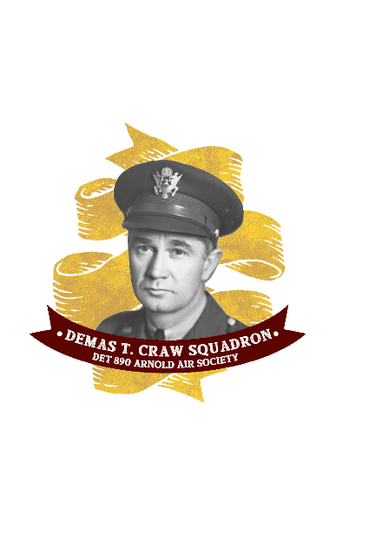

Arnold Air Society: Demas T. Craw Sq
A nationally recognized professional, honorary, service organization advocating the support of aerospace power. Professional because of its mission to further develop future Air Force officers, honorary because of the high standards for membership, and
service-oriented because of the contributions and assistance provided to the community, the campus, and officer commissioning programs.
To become part of AAS, you will be required to complete an
8-week candidacy process. Candidacy occurs after LLABs for about 2 hours and happens during both the fall and spring semester. For more information regarding AAS and on how to join, please be on the look-out from the Arnold Air Squadron Commanders during the semester.
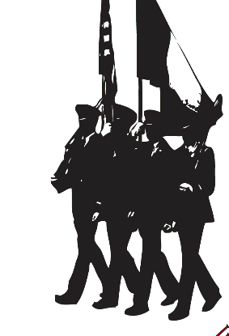

Drill Team: McConnell Escadrille
- An organization built on precision and excellence. After joining the Drill Team, cadets perform in drill and ceremonies with arms. They will learn all aspects of drill and ceremonies, customs and courtesies, and military professionalism. Members perform silent drill routines with rifles, a feat which requires practice, teamwork, and incredible precision.
To become part of the Drill Team you will be required to complete an 8-week candidacy process. Candidacy occurs typically on Sunday afternoons for about 2 hours and happens only during the Fall semester. For more information regarding Drill Team and how to join please be on the look-out from your schools Drill Team Commander during the semester.

13.1 UVA Key Locations

D

B
A

C - Slaughter Gym
D - Amphitheater
A - O-Hill
B - Detachment 890
B
C
D
A
E
C
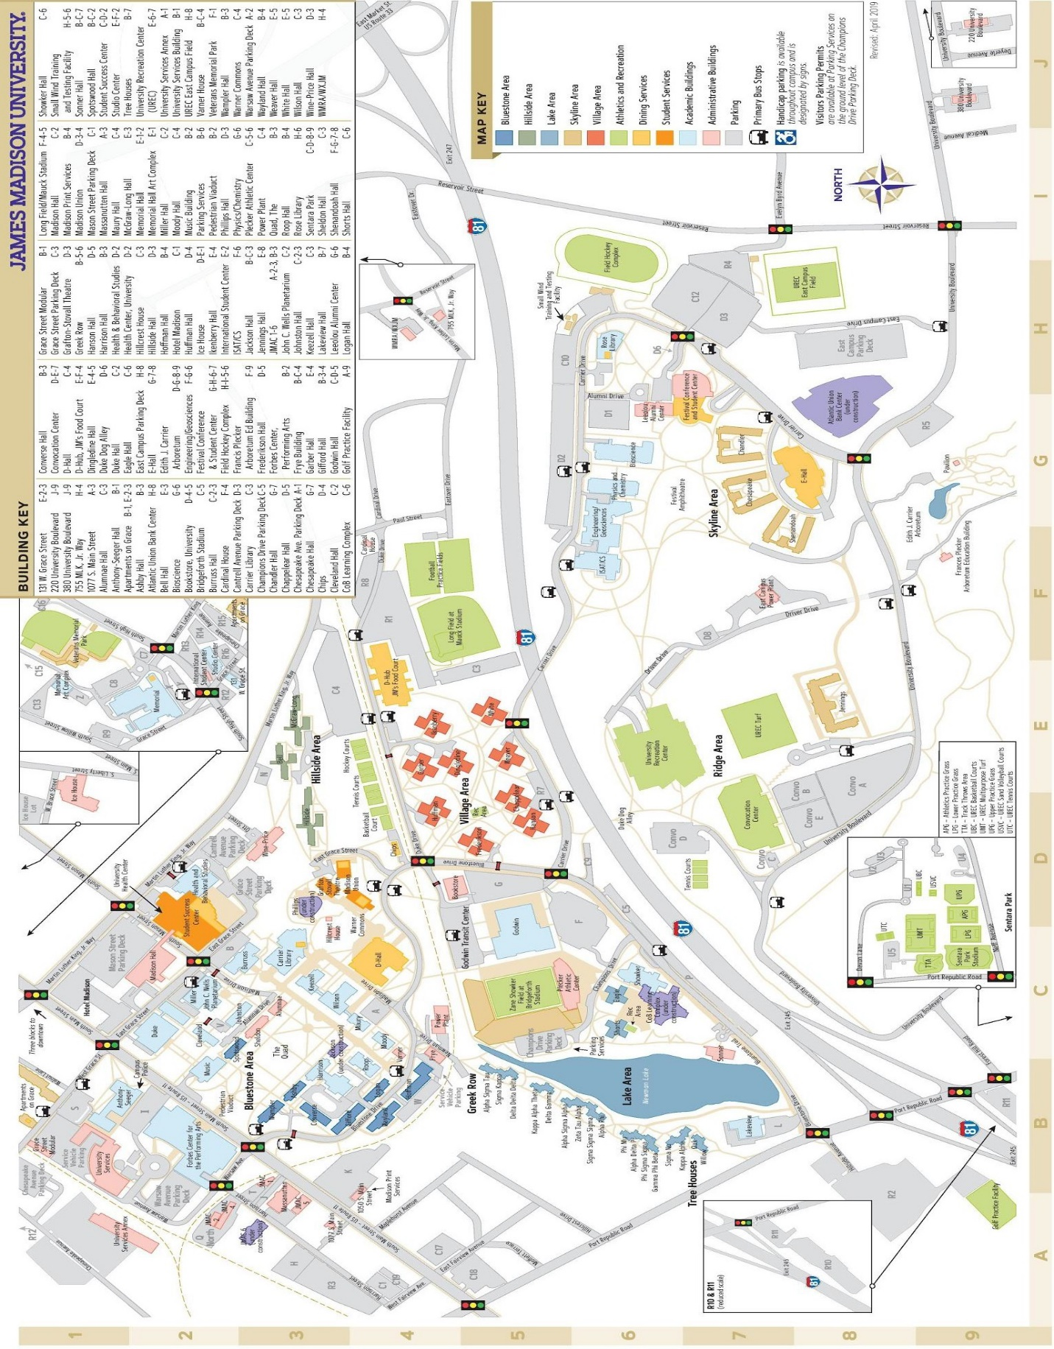

13.2. JMU Key Locations

A - ISAT Track
B - Memorial

C - The Quad
D - Godwin
E - Showker
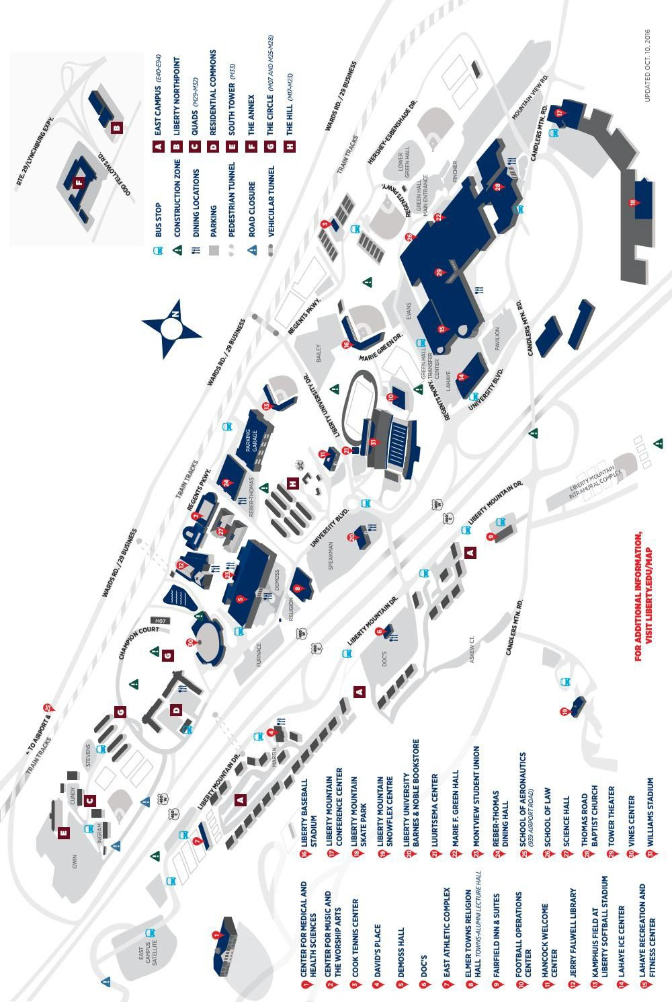

13.3. LU Key Locations

E

B

D

A

C

F

C - Vines Center
D - Reber Thomas Dining Hall
F – Circle Fields
A - DeMoss Hall B - Outdoor Track E - Green Hall

14. Resources

14.1. Air Force Documents.

14.1.1. AFI 36-2903. Dress and Personal Appearance of Air Force Personnel.
https://static.e-publishing.af.mil/production/1/af_a1/publication/afi36-2903/afi36-2903.pdf

14.1.2. AFH 33-337. Tongue and Quill.
https://static.e-publishing.af.mil/production/1/saf_cn/publication/afh33-337/afh33-337.pdf

14.1.3. AFMAN 91-203. Air Force Occupational Safety, Fire, and Health Standards.
https://static.e-publishing.af.mil/production/1/af_se/publication/afman91-203/afman91-203.pdf

14.1.4. AFMAN 36-2203. Drill and Ceremonies.
https://static.e-publishing.af.mil/production/1/af_a1/publication/afman36-2203/afman36-2203.pdf

14.1.5. AFI 36-2905. Fitness Program.
https://www.afpc.af.mil/Portals/70/documents/06_CAREER%20MANAGEMENT/03_Fitness%20Program/AFI%2036-2905_FITNESS%20PROGRAM.pdf?ver=2018-08-22-115632-260

14.2. Recommended Resources.

14.2.1. AFROTC Detachment 910 Uniform Guide.
https://www.youtube.com/watch?v=HOzninJJLjo&t=271s

14.2.2. How to set up Air Force Service Dress Blues Uniform.
https://www.youtube.com/watch?v=_gFuVAmXsjo&t=12s

14.2.3. NJROTC | How to Shine Your Shoes.
https://www.youtube.com/watch?v=2ABwi6GUUR4&t=42s

14.2.4. ORI Procedures.
https://www.youtube.com/watch?v=AosCLOdpZrY&t=4s

14.2.5. Open Ranks Inspection.
https://www.youtube.com/watch?v=bycyU430h8Y

14.2.6. Glossary of Military Terms.
https://www.afrotc.com/glossary/

14.2.7. Arnold Air Society and Silver Wings.
https://aas-sw.org/

14.2.8. AFROTC Frequently Asked Questions.
https://afrotc.as.uky.edu/afrotc-faqs

14.2.9. Detachment 890 Road Guard Procedures.
https://www.youtube.com/watch?v=5hDPs4FKCkA

14.2.10. Flight Drill – AFROTC Detachment 485.
https://www.youtube.com/watch?v=gxBOsDb-p_I

14.2.11. DFAC Entry Procedures.
https://www.youtube.com/watch?v=AqoI2wkWXR8

14.2.12. DFAC Dining Procedures.
https://www.youtube.com/watch?v=pyqoDFrCGXQ

14.2.13. Air Force Fitness Assessment.
https://www.youtube.com/watch?v=z6cNHsw-EWI

14.2.14. Nutrition Basics.
https://www.youtube.com/watch?v=IZDMBvFOKsw

14.2.15. Scholarships – AFROTC.
https://www.afrotc.com/scholarships/

14.2.16. Air Force Website.
https://www.airforce.com/

14.2.17. Air Force Reserve Officer Training Corps.
https://www.af.mil/About-Us/Fact-Sheets/Display/Article/104478/air-force-reserve-officer-training-corps/#:~:text=AFROTC%20is%20the%20largest%20and,based%20on%20Air%20Force%20requirements.

14.2.18. Most Current Field Training Manual.

14.2.19. Special Thanks to Detachment 847 Cadet Handbook.
https://www.angelo.edu/live/files/24789-cadetguide

Notes

